Name ; Alveena naz
Reg No.FA25-BSE-010

Activity1:
// main class
public class JavaApplication35 {
public static void main(String[] args) {
SalariedEmployee se = new SalariedEmployee("John","111-121",800);
HourlyEmployee he = new HourlyEmployee("Karen","564-234",16.75,40);
CommisionEmployee ce = new CommisionEmployee("Sue","333-333",0.06,10000);
BasePlusCommisionEmployee be = new BasePlusCommisionEmployee("Bob","444-444",5000,0.04,300);
Employee employee[] = new Employee[4];
employee[0] = se;
employee[1] = he;
employee[2] = ce;
employee[3] = be;
//overriden method call
for(int i=0;i<employee.length;i++){
System.out.println(employee[i].earning());
}
for(int i =0;i<employee.length;i++){
if(employee[i] instanceof BasePlusCommisionEmployee ){
BasePlusCommisionEmployee emp =(BasePlusCommisionEmployee)employee[i];
emp.setBaseSalary(1.10*emp.getBaseSalary());
System.out.println("The base salary with 10% increase is " +emp.getBaseSalary() );
employee[i] = emp;
}

System.out.println("Earning: " + employee[i].earning());
}

}

}
//employee
public abstract class Employee {
private String name;
private String SSN;
Employee(String n , String SSN){
this.name = n;
this.SSN = SSN;
}
@Override
public String toString(){
return "name:" + name + "/nSSN: " + SSN;
}
public abstract double earning();

}
//salaried employee
public class SalariedEmployee extends Employee {
private double weeklySalary;
SalariedEmployee(String n , String SSN,double salary){
super(n,SSN);
this.weeklySalary=salary;
}
@Override
public double earning(){
return weeklySalary;
}
}
//hourly employee
public class HourlyEmployee extends Employee{
private double wage;
private double hour;
HourlyEmployee(String n , String SSN,double wage,double hour){
super(n,SSN);
this.wage= wage;
this.hour=hour;
}
@Override
public double earning(){
if(hour<=40){
return wage * hour;
}
else{
return 40 * wage + (hour-40) * wage + 1.5;
}
}
}
//commission employee
public class CommisionEmployee extends Employee{
private double commisionRate;
private double grossSale;
CommisionEmployee(String n , String SSN,double rate,double sale){
super(n,SSN);
this.commisionRate=rate;
this.grossSale=sale;
}
@Override
public double earning(){
return commisionRate*grossSale;
}
}
//base pus commission
public class BasePlusCommisionEmployee extends CommisionEmployee{
private double baseSalary;
BasePlusCommisionEmployee(String n , String SSN,double base, double rate,double sale){
super(n,SSN,base,rate);
this.baseSalary=sale;
}
public void setBaseSalary(double sale){
this.baseSalary=sale;
}
public double getBaseSalary(){
return baseSalary;
}
@Override
public double earning(){
return baseSalary+ super.earning();
}
}
OUTPUT:
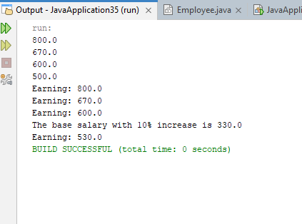

Activity 2:
public class JavaApplication35 {
public static void main(String[] args) {
SalariedEmployee se = new SalariedEmployee("John","111-121",800);
HourlyEmployee he = new HourlyEmployee("Karen","564-234",16.75,40);
CommisionEmployee ce = new CommisionEmployee("Sue","333-333",0.06,10000);
BasePlusCommisionEmployee be = new BasePlusCommisionEmployee("Bob","444-444",5000,0.04,300);
Employee employee[] = new Employee[4];
employee[0] = se;
employee[1] = he;
employee[2] = ce;
employee[3] = be;
//overriden method call
for(int i=0;i<employee.length;i++){
System.out.println(employee[i].earning());
}
for(int i =0;i<employee.length;i++){
if(employee[i] instanceof BasePlusCommisionEmployee ){
BasePlusCommisionEmployee emp =(BasePlusCommisionEmployee)employee[i];
emp.setBaseSalary(1.10*emp.getBaseSalary());
System.out.println("The base salary with 10% increase is " +emp.getBaseSalary() );
employee[i] = emp;
}

System.out.println("Earning: " + employee[i].earning());
}

}

}
//employee
public abstract class Employee {
private String name;
private String SSN;
Employee(String n , String SSN){
this.name = n;
this.SSN = SSN;
}
@Override
public String toString(){
return "name:" + name + "/nSSN: " + SSN;
}
public abstract double earning();

}
//salaried employee
public class SalariedEmployee extends Employee {
private double weeklySalary;
SalariedEmployee(String n , String SSN,double salary){
super(n,SSN);
this.weeklySalary=salary;
}
@Override
public double earning(){
return weeklySalary;
}
}
//hourly employee
public class HourlyEmployee extends Employee{
private double wage;
private double hour;
HourlyEmployee(String n , String SSN,double wage,double hour){
super(n,SSN);
this.wage= wage;
this.hour=hour;
}
@Override
public double earning(){
if(hour<=40){
return wage * hour;
}
else{
return 40 * wage + (hour-40) * wage + 1.5;
}
}
}
//commission employee
public class CommisionEmployee extends Employee{
private double commisionRate;
private double grossSale;
CommisionEmployee(String n , String SSN,double rate,double sale){
super(n,SSN);
this.commisionRate=rate;
this.grossSale=sale;
}
@Override
public double earning(){
return commisionRate*grossSale;
}
}
//base pus commission
public class BasePlusCommisionEmployee extends CommisionEmployee{
private double baseSalary;
BasePlusCommisionEmployee(String n , String SSN,double base, double rate,double sale){
super(n,SSN,base,rate);
this.baseSalary=sale;
}
public void setBaseSalary(double sale){
this.baseSalary=sale;
}
public double getBaseSalary(){
return baseSalary;
}
@Override
public double earning(){
return baseSalary+ super.earning();
}
}
OUTPUT:


Task 1:
//main class
public class JavaApplication36 {
public static void main(String[] args) {
Package p = new Package();
TwoDayPackage tdp = new TwoDayPackage("alveena","attock",34.5,100,50);
OvernightPackage op = new OvernightPackage("sanua","lahore",34.5,100,25);
tdp.calculatecost();
op.calculatecost();
p = tdp;
System.out.println("after dynamic method dispatch: " +p.calculatecost());

p = op;
System.out.println("after dynamic method dispatch: " +p.calculatecost());
}

}
// two day package
public class TwoDayPackage extends Package{
double flatFee;
TwoDayPackage(){}
TwoDayPackage(String n, String add, double w,double c,double fee){
super(n,add,w,c);
this.flatFee=fee;
}
@Override
public double calculatecost(){
return super.calculatecost() + flatFee;
}
}
//over night package
public class OvernightPackage extends Package{
double additionalFee;
OvernightPackage(){}
OvernightPackage(String n, String add, double w,double c,double fee){
super(n,add,w,c);
this.additionalFee=fee;
}
@Override
public double calculatecost(){
return super.calculatecost() +additionalFee;
}
}

OUTPUT:
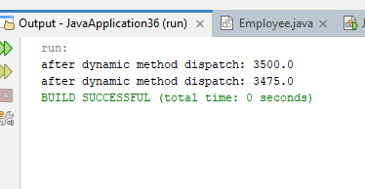

Task 2:
//main class
public class JavaApplication37 {
public static void main(String[] args) {
Professor pf = new Professor("John",51);
Student s = new Student("ali",3.74);
Person p[] = new Person[2];
p[0] = pf;
p[1]=s;
for(int i =0;i<p.length;i++){
if(p[i] instanceof Professor){
Professor ps = (Professor)p[i];
ps.setnumberOfPublications(100);
}
System.out.println("Perfomance: " + p[i].outStanding());
}
}

}
//Person
public abstract class Person {
private String name;
Person(){}
Person(String n){
this.name=n;
}
public void setName(String n){
this.name=n;
}
public String getName(){
return name;
}
public abstract boolean outStanding();
}
//Professor
public class Professor extends Person{
private int numberOfPublications;
Professor(){}
Professor(String n , int publications){
super(n);
this.numberOfPublications=publications;
}
public void setnumberOfPublications(int publications){
this.numberOfPublications=publications;
}
public int getnumberOfPublications(){
return numberOfPublications;
}
@Override
public boolean outStanding(){
if(numberOfPublications>50)
return true;

return false;
}
}
//Student
public class Student extends Person {
private double CGPA;
Student(){}
Student(String n,double cgpa){
super(n);
this.CGPA=cgpa;
}
public void setCGPA(double cgpa){
this.CGPA=cgpa;
}
public double getCGPA(){
return CGPA;
}
@Override
public boolean outStanding(){
if(CGPA>3.5)
return true;

return false;
}
}
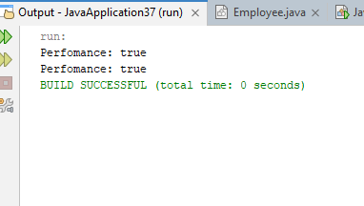

Task 3:

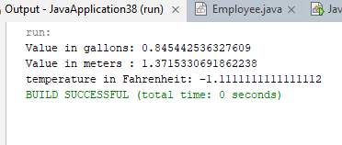
//main class
public abstract class Convert {
double val1;
double val2;
Convert(){};
Convert(double v1){
this.val1=v1;

}
public abstract void convert();
}
public class LitersToGallons extends Convert{
LitersToGallons(){}
LitersToGallons(double v1){
super(v1);
}
@Override
public void convert(){
val2 = val1/3.785;
System.out.println("Value in gallons: " + val2);
}
}
public class FeetToMeters extends Convert{
FeetToMeters(){}
FeetToMeters(double v1){
super(v1);
}
@Override
public void convert(){
val2 = val1/3.281;
System.out.println("Value in meters : " + val2);
}
}
public class FahrenheitToCelsius extends Convert{
FahrenheitToCelsius(){}

FahrenheitToCelsius(double v1){
super(v1);
}
@Override
public void convert(){
val2 =(val1 - 32) * 5/9 ;
System.out.println("temperature in Fahrenheit: " + val2);
}
}

